Progressive contribution week2
1. Running the jupyter image using the command: $ docker run -p 8888:8888 jupyter/datascience-notebook

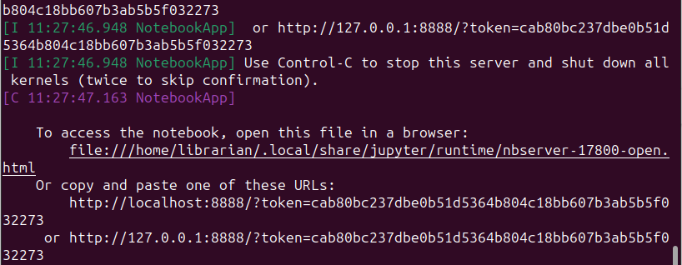

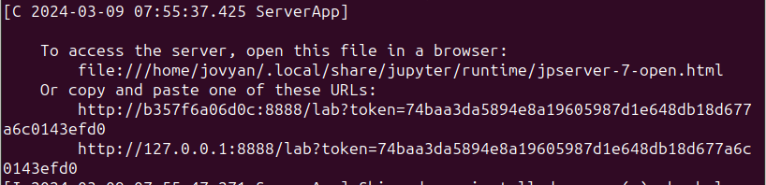
2. The above commands were a success. Jupyter notebook was started with the command:j $ jupyter notebook
3. Jupyter notebook lab was also started to access CLI using the command: $ jupyter lab

